Developing a Transparent Anaemia Prediction Model Empowered With Explainable Artificial Intelligence

Increasing age often affecting human health with various disease which include decrease of ‘haemoglobin’ also known as reduction of ‘red blood cells’ or anaemic patient. Anaemic patients expose to more number of diseases and situation get more horrible when detection get delayed. Currently no easy suitable technique available which can predict anaemic condition. All existing technique predominantly rely on statistics and are trained on clinical risk scores, are frequently incapable of providing practical solutions and meaningful insights into anaemia diagnosis.

To improve anaemic prediction rate along with explanation which is known as Black-box for AI algorithms, author of this paper employing various AI algorithms such as Decision Tree, SVM, KNN and Gradient Boosting. Prediction of each model will be explained with the help of SHAP and LIME explanation tools. This tool will explain medical expert about those features which are contributing to make prediction. By seeing this explanation medical experts can easily understand weather AI model has used suitable features to make correct prediction or not.

In the past many AI algorithms were introduced but medical profession unwilling to accept this algorithms because of lack of explanation. So Author of this paper utilizing AI and explanation tool to prove AI prediction result.

To make accurate prediction author utilize multiple AI algorithms and then measured performance of each algorithms in terms of accuracy, precision, recall and FSCORE. Among all algorithms SVM proved to high performer with an accuracy of over 98%. To train above algorithms author has used Anaemia dataset which can be download from below URL.

<https://www.kaggle.com/datasets/biswaranjanrao/anemia-dataset/data>

Above dataset contains various features such as Gender, Haemoglobin and other features.

**Abstract**: The worldwide health epidemic of anaemia which is a condition with low levels of red blood cells or haemoglobin requires accurate prediction models to act promptly and improve patient outcomes because it is widespread and has different causes. The effective management of anaemia is piled with obstructions, which may include the variability of diagnostic criteria, the resource limitations of healthcare, and the multifactorial nature of the disease including nutritional deficiencies, chronic disease, and genetic factors. Conventional anaemia prediction models, that predominantly rely on statistics and are trained on clinical risk scores, are frequently incapable of providing practical solutions and meaningful insights into anaemia diagnosis. There is a growing interest in focusing on Artificial Intelligence (AI) use for anaemia prediction, however, traditional AI models (black boxes) lack transparency, which causes doctors not to pick them up for practical usage. Actionable insights that are enabled by transparent AI models (white boxes) based on the explainable AI methodologies reveal the rationales of the prediction, clarify the features that are responsible for them, and help clinicians and healthcare providers. In propose work, a transparent anaemia prediction model (white box) empowered by explainable AI techniques is proposed to address the limitations of black boxes in terms of transparency. The proposed model utilizes machine learning algorithms such as Support Vector Machine (SVM), Decision Trees, K-Neighbors Classifier, and Gradient Boosting Classifier, enhanced with Explainable AI (XAI) techniques like SHAP and LIME. With the integration of explainable AI techniques like SHapley Additive explanations (SHAP), and Local Interpretable Model-agnostic Explanations (LIME), the proposed model offers insights into the underlying factors influencing anaemia predictions. The proposed model, significantly, represents exceptional growth in the healthcare sector and helps in bridging the gap between predictive performance and clinical interpretability, thus improving patient care and disease management strategies. The model simulation results are showing promising results in terms of the accuracy (98.13%) and the miss-rate (1.87%) which are the superior performance compared to the previous published approaches.

Extension Concept

In propose paper author has concentrate on measuring performance of multiple ML algorithms but not concentrating on optimizing algorithm performance with the help of Hybrid model. So in this extension we have form an hybrid model by combining multiple base estimators such as Random Forest and XGBOOST and this base estimators will get train with the help of Voting Classifier which will vote each algorithm accuracy and then vote the one with highest accuracy. So with hybrid model we can always come up with algorithm with high accuracy.

SCREEN SHOTS

We have code this project using JUPYTER notebook and below are the code and output screen with blue colour comments

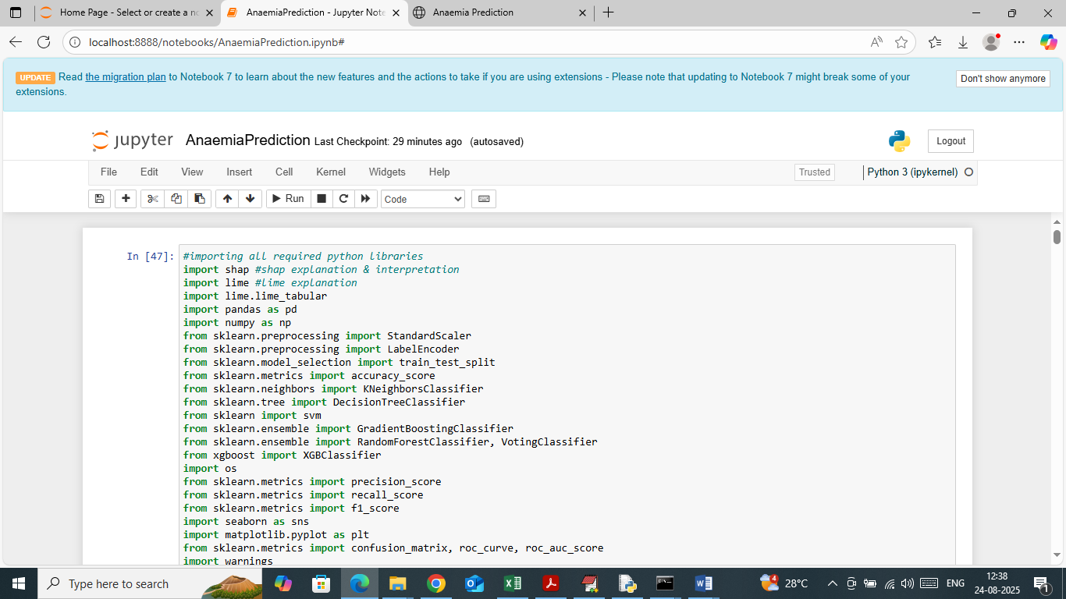

In above screen importing required python classes and packages

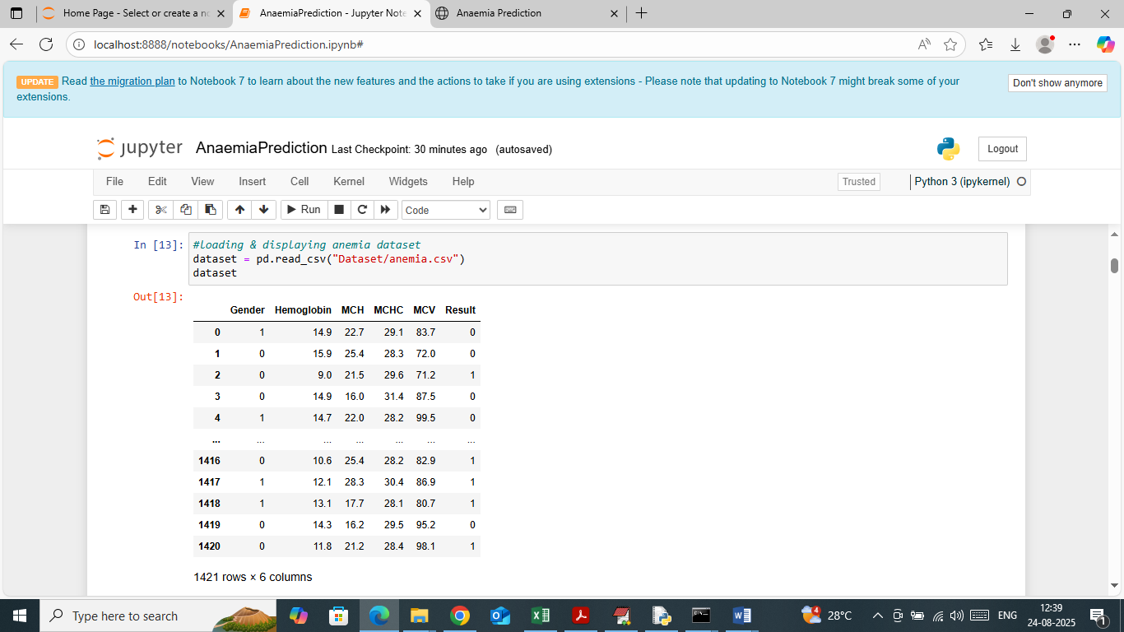

In above screen loading and displaying Anaemia dataset

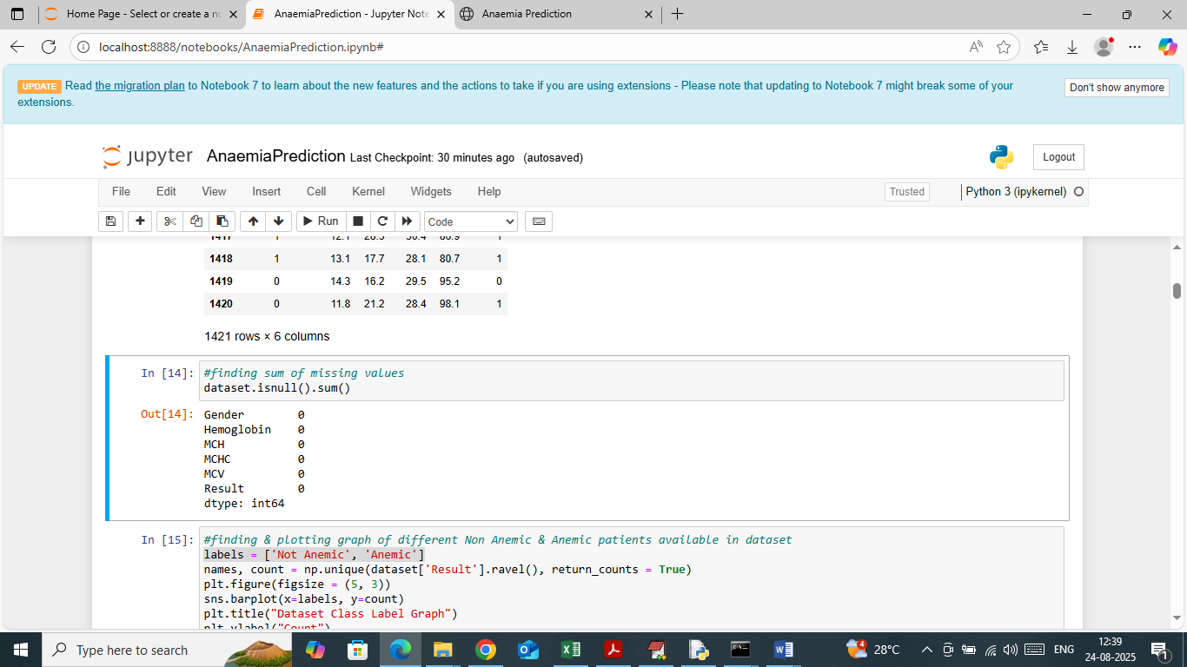

In above screen analysing dataset to identify missing values in the dataset and in above screen can see dataset contains no missing data

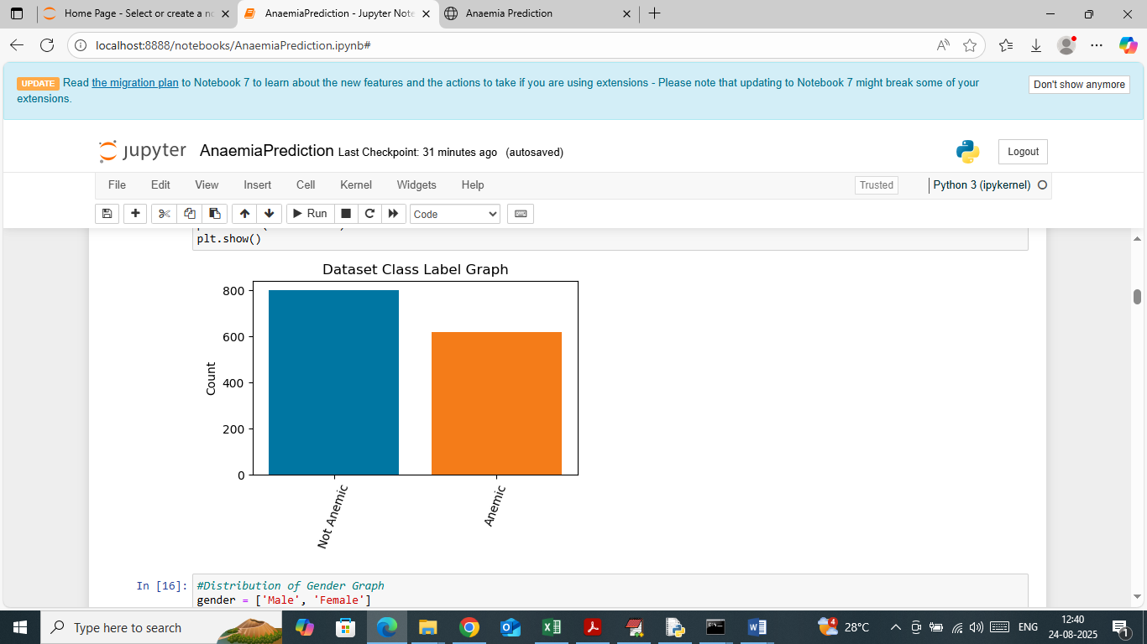

In above screen exploring dataset to identify number of Anaemic and non-Anaemic patients available in dataset. In above graph x-axis represents anaemic type and y-axis represents counts.

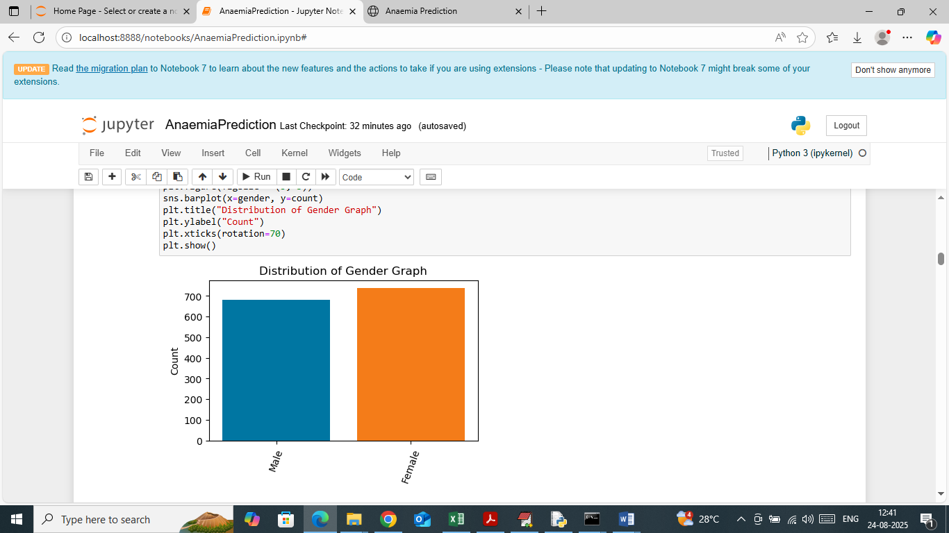

In above screen visualizing graph of gender count with and without Anaemic patients where x-axis represents Gender and y-axis represents counts

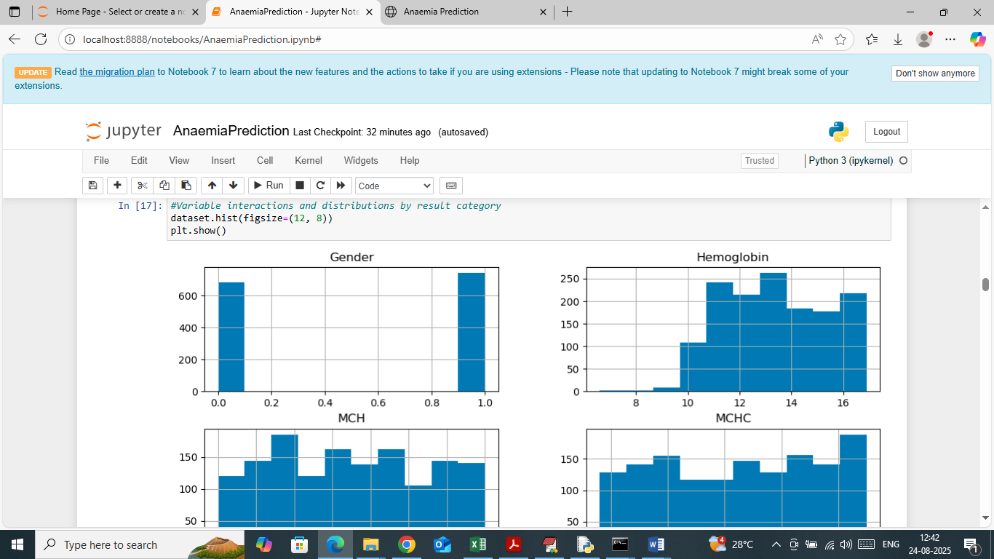

In above screen visualizing dataset features distribution graph which will explain how values of each features or columns distributed in range

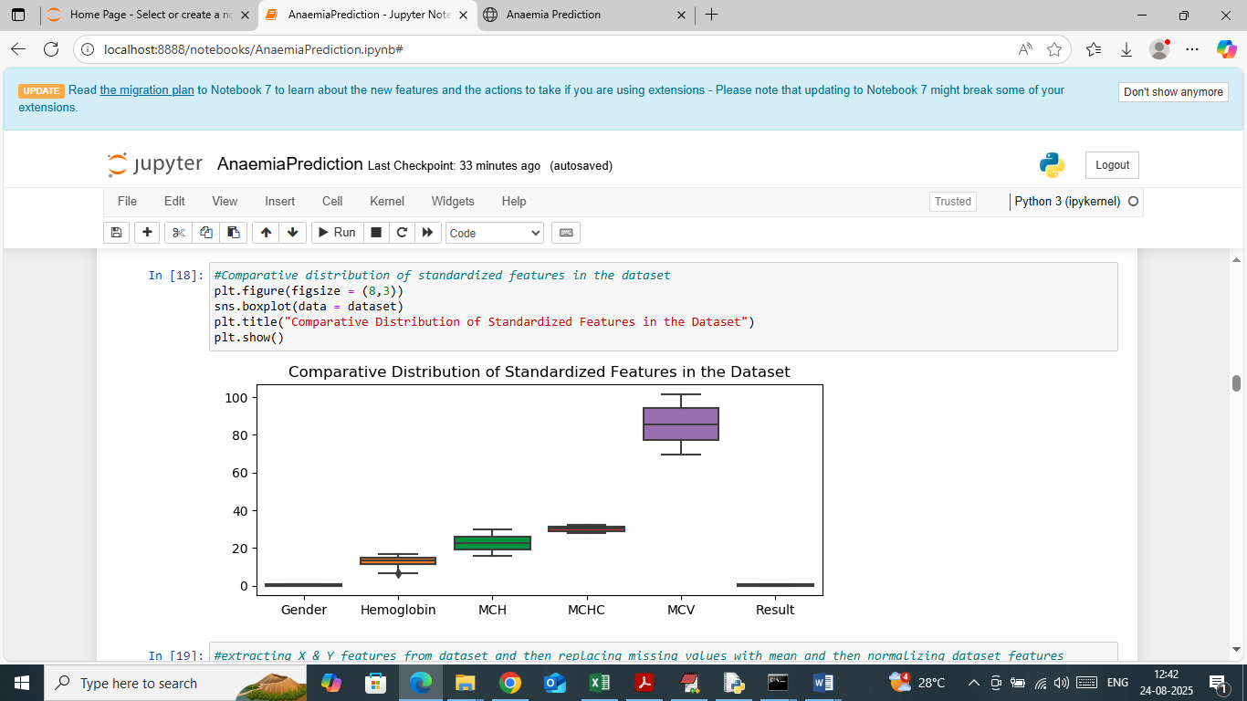

In above graph also visualizing features distribution graph where x-axis represents Feature Name and y-axis represents range of features values from starting to end in each box plot.

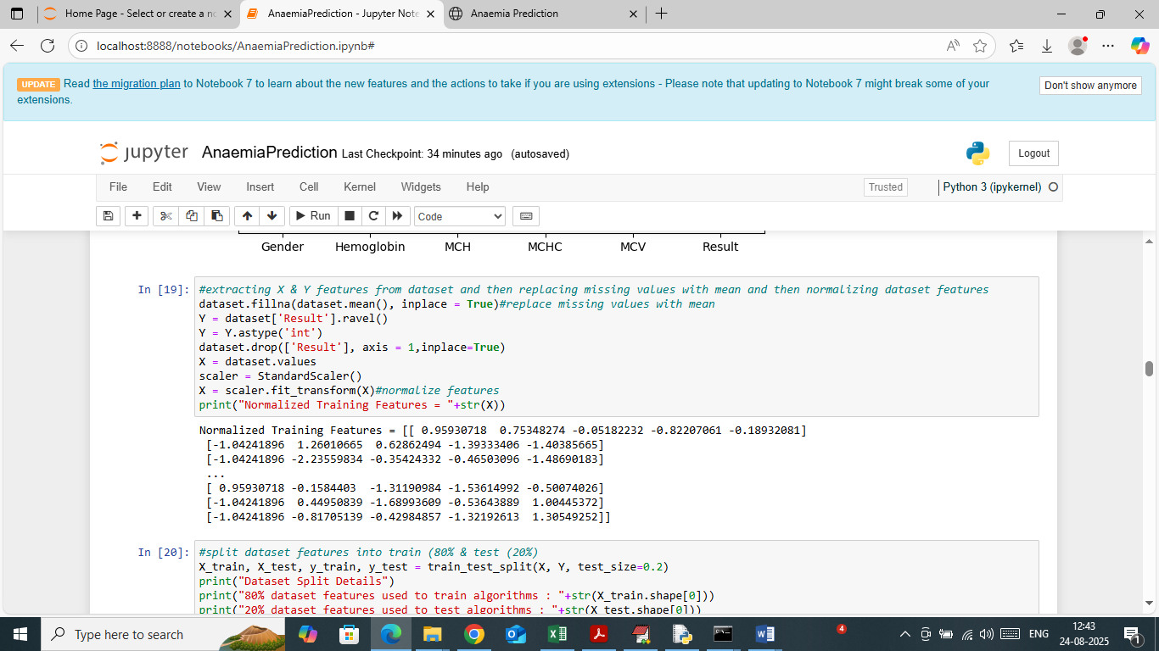

In above screen applying dataset pre-processing such as extracting X and Y training features and then replacing missing features with mean and then normalizing all training features using Standard Scaler algorithm. In above screen can see normalized features values

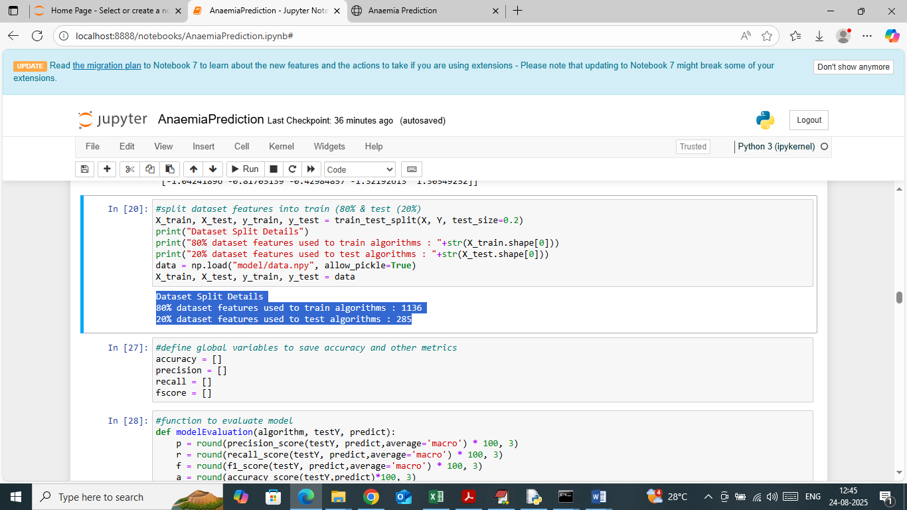

In above screen splitting dataset into train and test where application using 80% data for training and 20% for testing and in blue text can see train and test data size. In next block defining function to calculate accuracy and other metrics

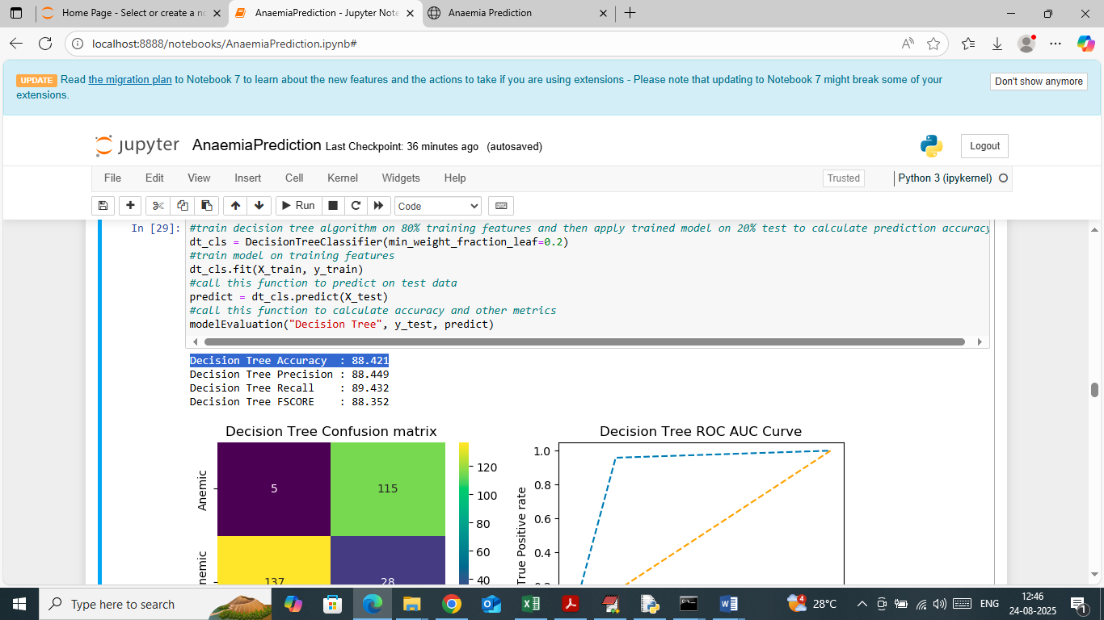

In above screen training Decision Tree algorithm on 80% data and then trained model applied on 20% test data to get an accuracy of 88% and can see other metrics like precision, recall and FSCORE. In below screen showing confusion matrix and ROC graph

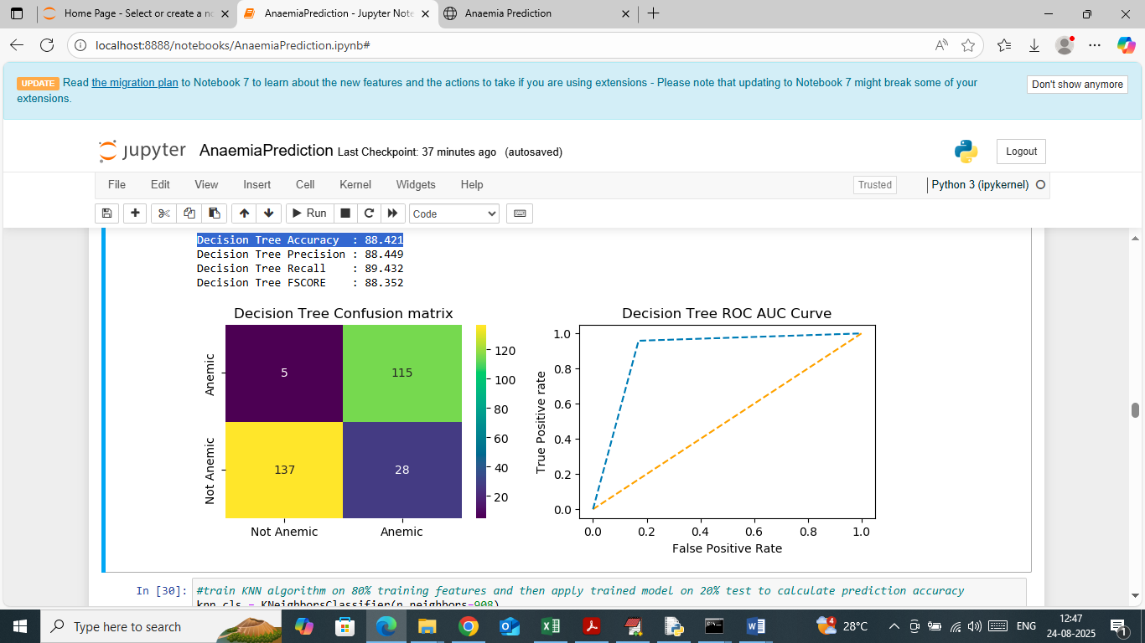

In above Decision Tree confusion matrix graph x-axis represents Predicted Labels and y-axis represents True Labels and then green and yellow colour boxes in diagonal represents correct prediction count and remaining all blue boxes represents incorrect prediction count which are very few. In ROC graph x-axis represents False Positive Rate and y-axis represents ‘True Positive Rate’. If blue line comes on top of orange line then all predictions are True else false.

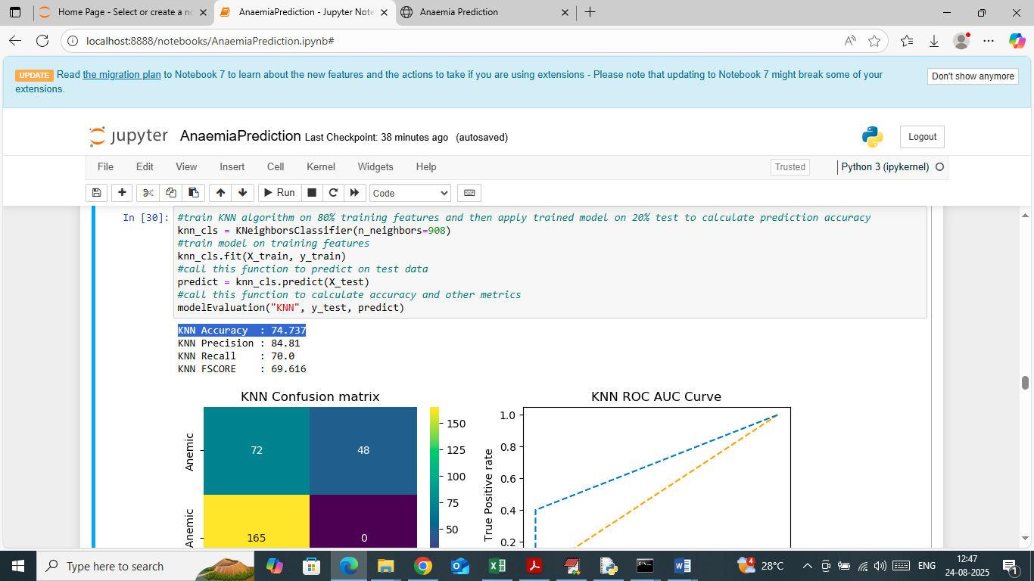

In above screen KNN algorithm which got 74% accuracy and can see other metrics result also

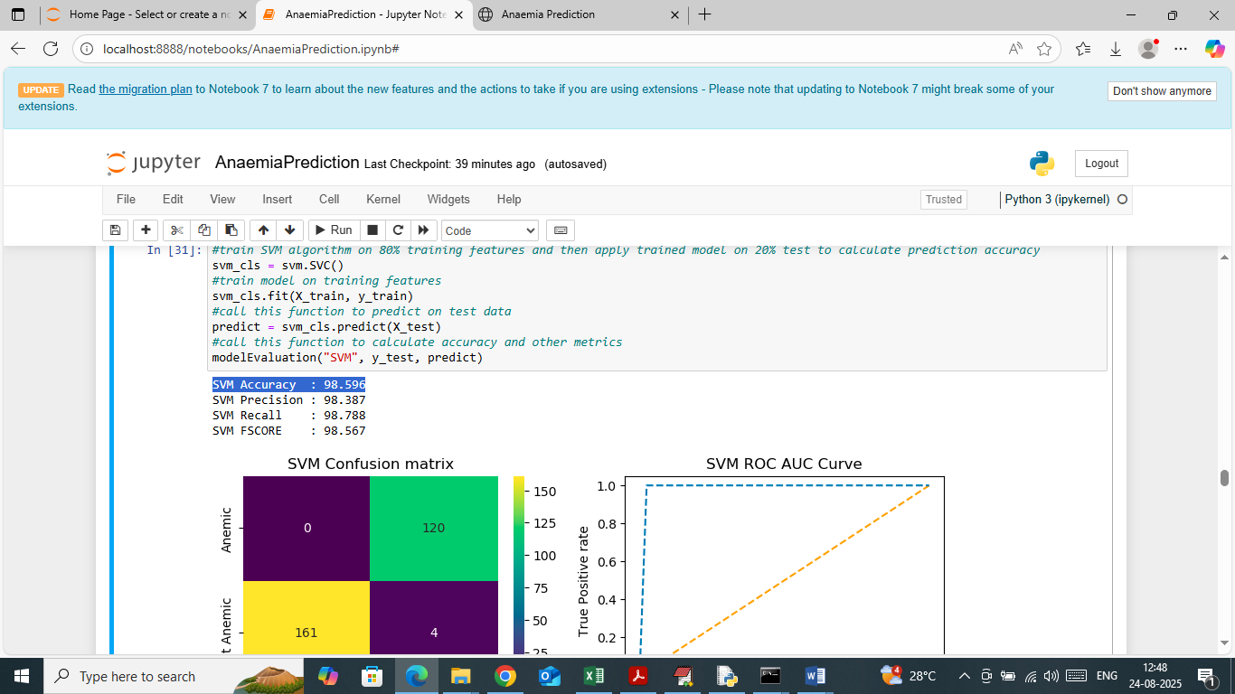

In above screen SVM algorithm which got 98% accuracy and can see other metrics result also

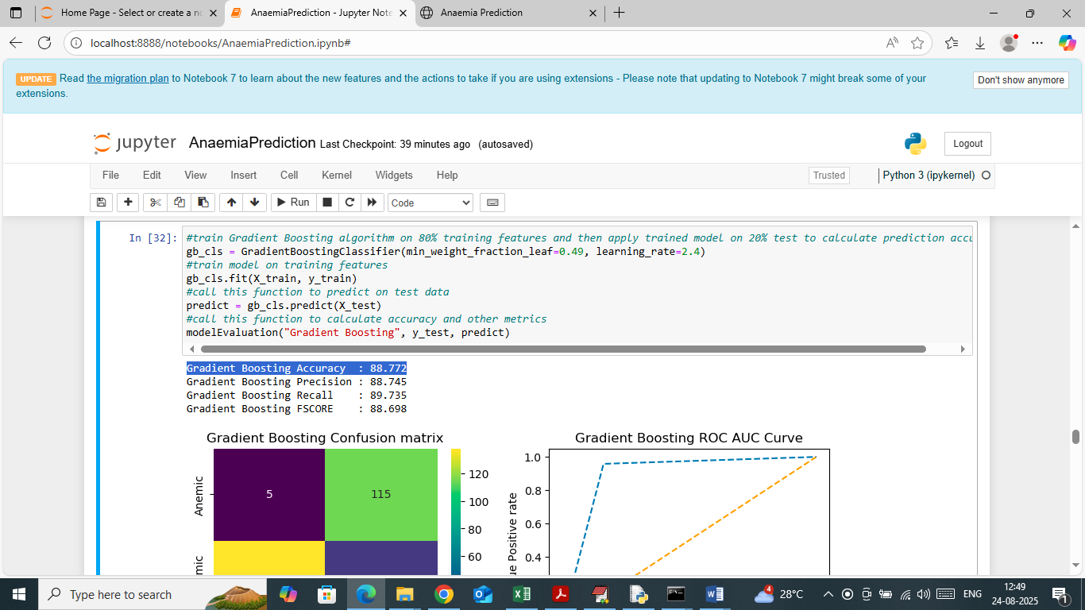

In above screen Gradient Boosting algorithm which got 88.77% accuracy and can see other metrics result also

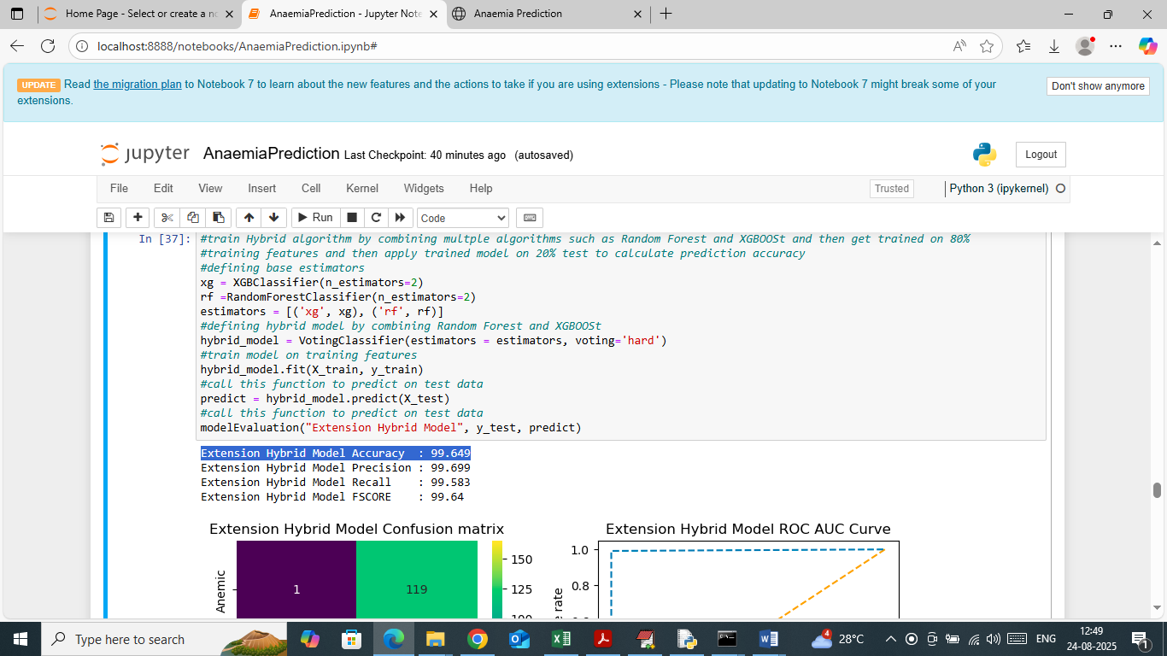

In above screen training extension hybrid model which got 99.64% accuracy and can see other metrics result also

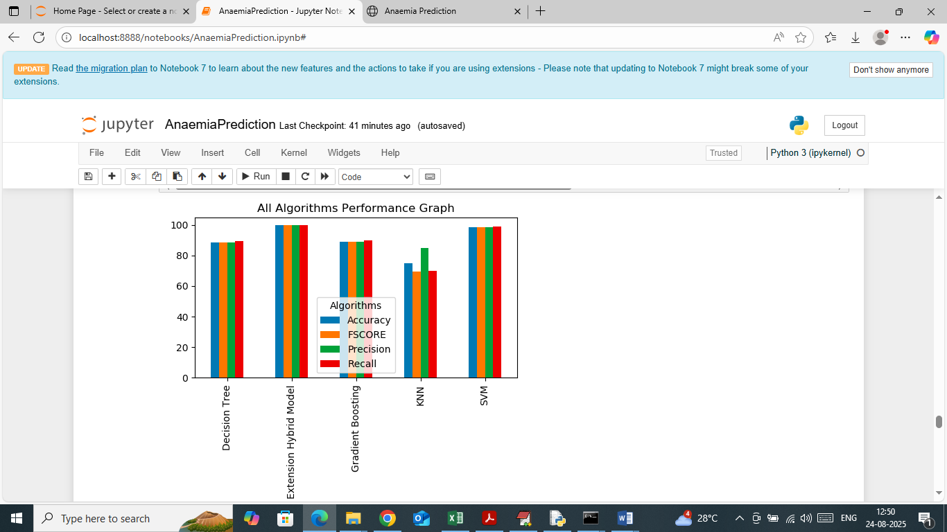

In above screen showing comparison graph between all algorithms where x-axis represents algorithm names and y-axis represents accuracy and other metrics in different colour bars

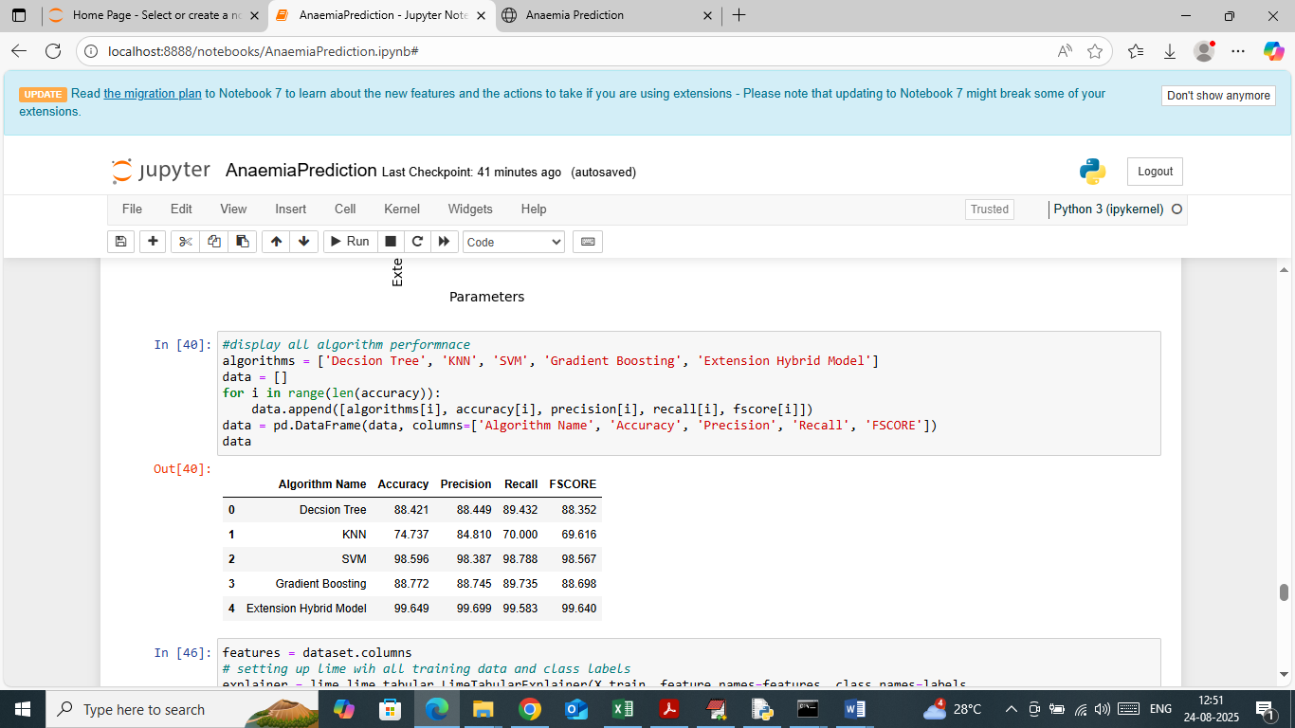

In above screen displaying all algorithms performance in tabular format where propose SVM and extension hybrid model got high accuracy

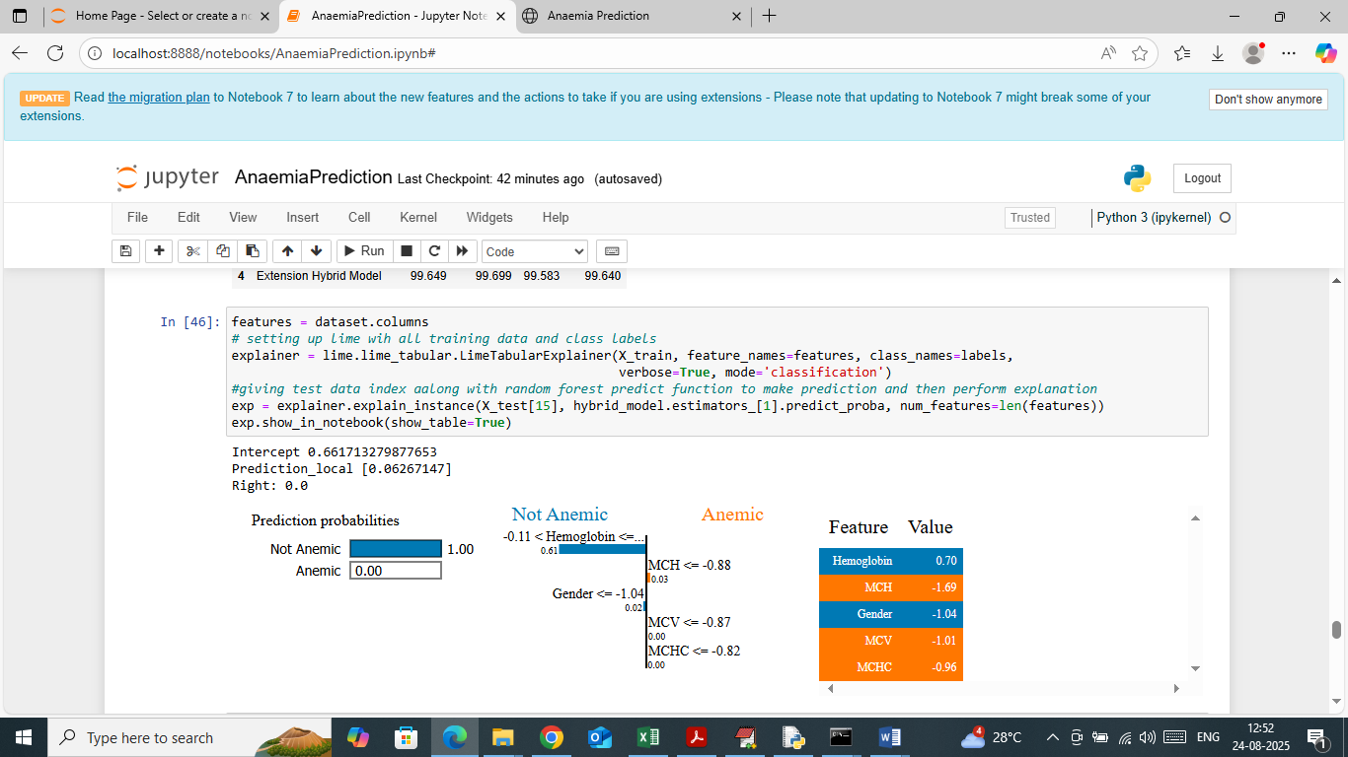

In above screen applying LIME interpretation on predicted values and then in first graph Lime explaining predicted class is ‘Not Anaemic’ with 100% probability and Anaemic got 0% Probability. In second and third graph explaining which features or column names from dataset contributing most for above class prediction.

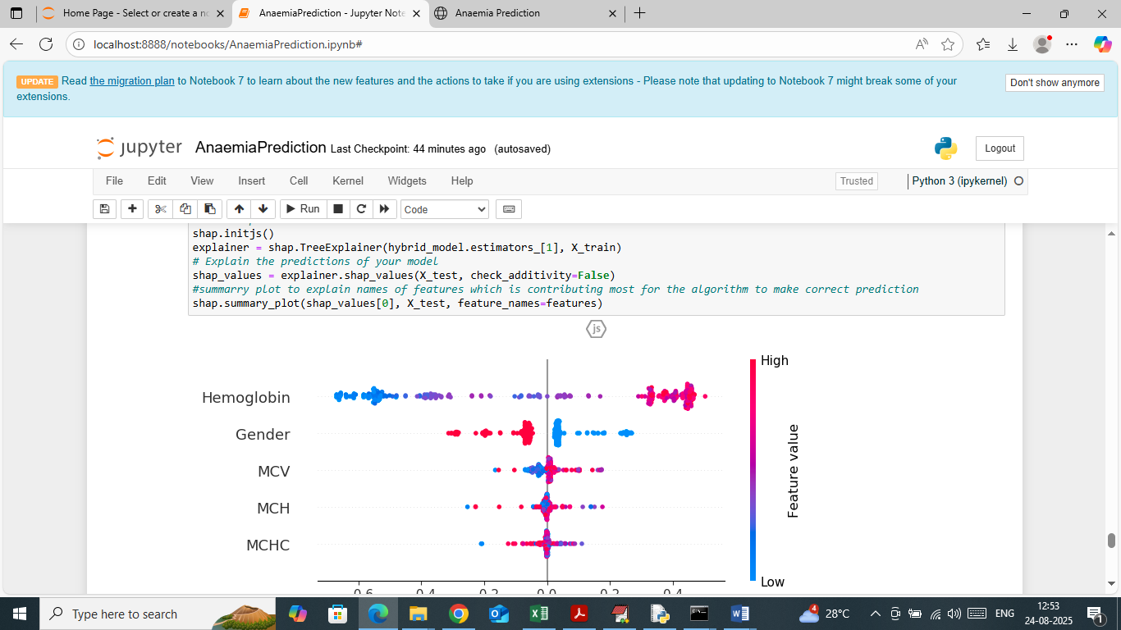

In above screen explaining prediction with SHAP summary plot and then explaining which features contributing most for prediction. In above graph features which is having more number of colour dots is contributing most for prediction.

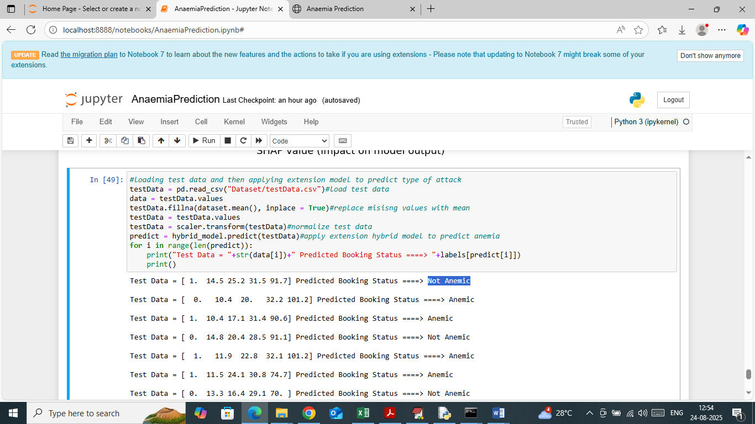

In above screen loading test dataset and then processing and applying extension model to predict Anaemia type. In output area in square bracket can see Test data values and after arrow ==🡺 symbol can see predicted Anaemia type.

WEB OUTPUT

To run web prediction double click on ‘runFlask.bat’ file to start flask server and then will get below page

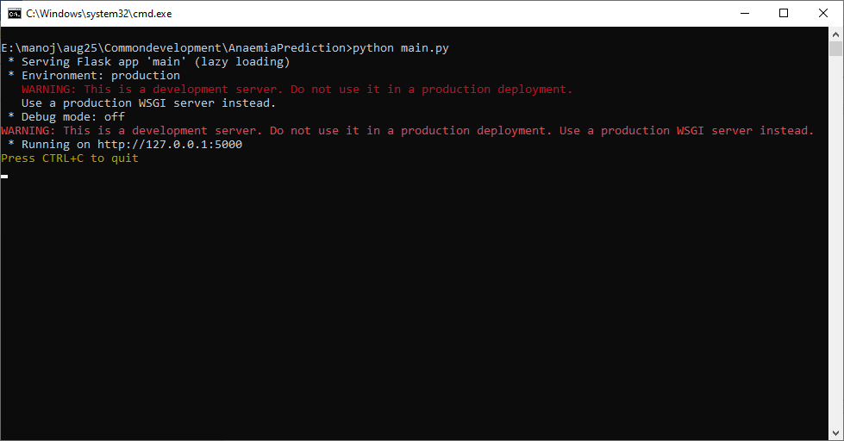

In above screen flask server started and now open browser and enter URL as <http://127.0.0.1:5000/index> and then press enter key to get below page

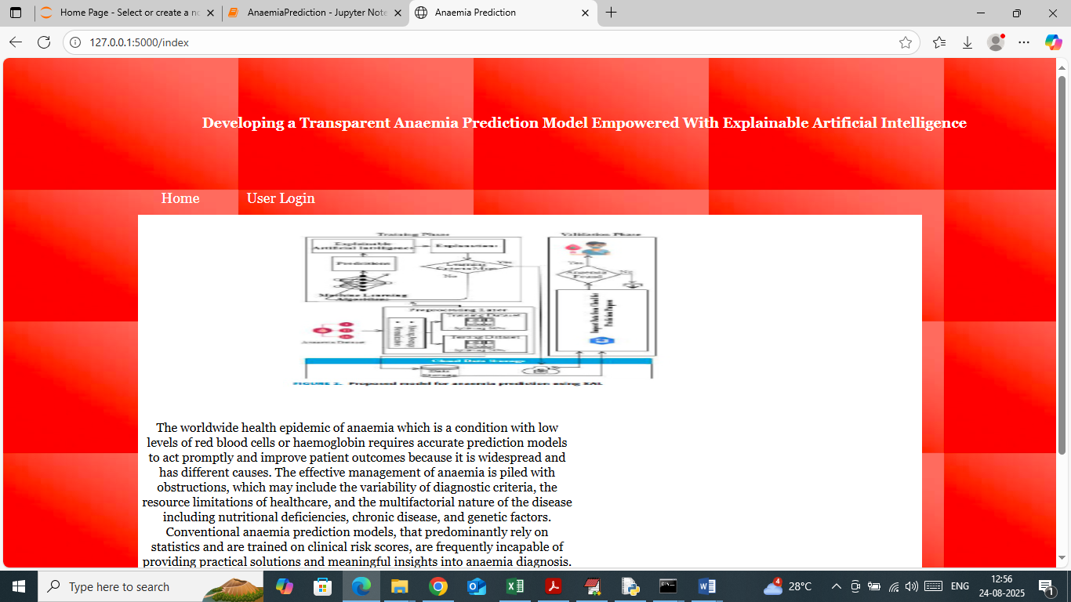

In above screen click on ‘User Login’ link to get below page

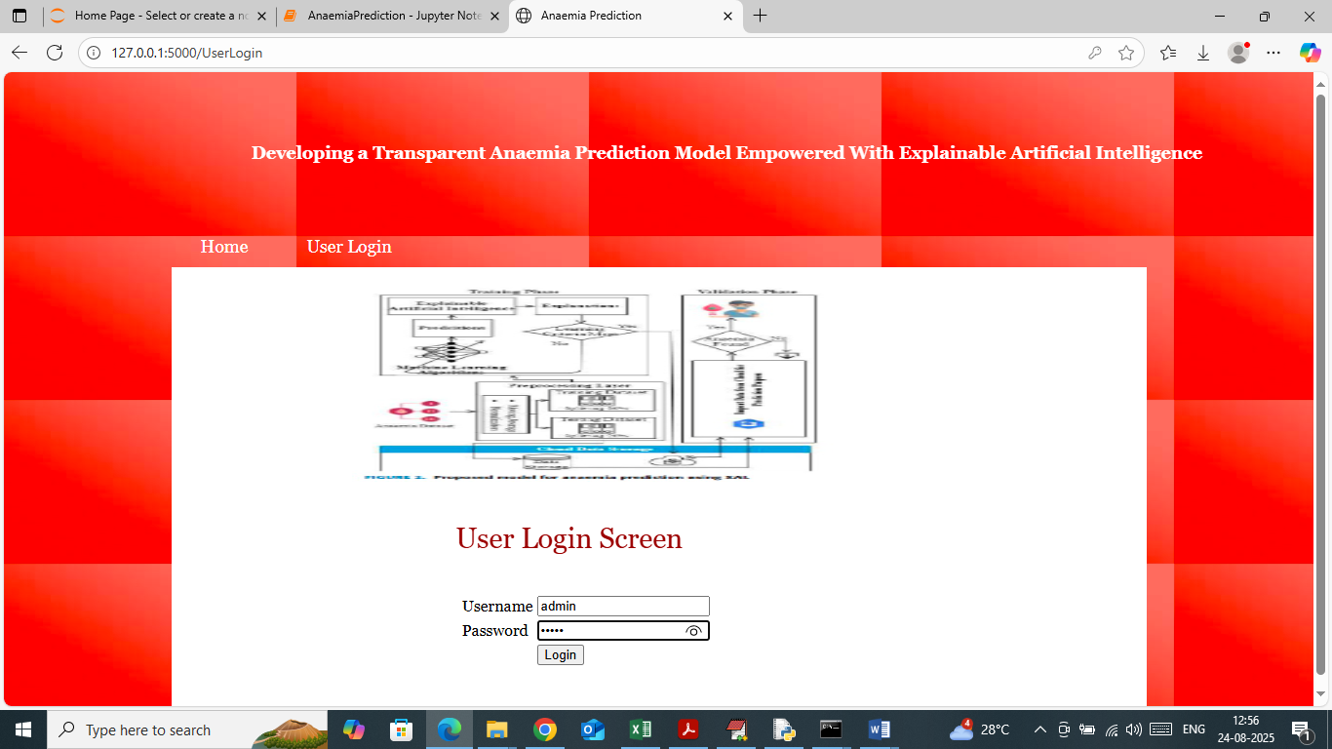

In above screen user is login by entering username and password as ‘admin and admin’. After login will get below page

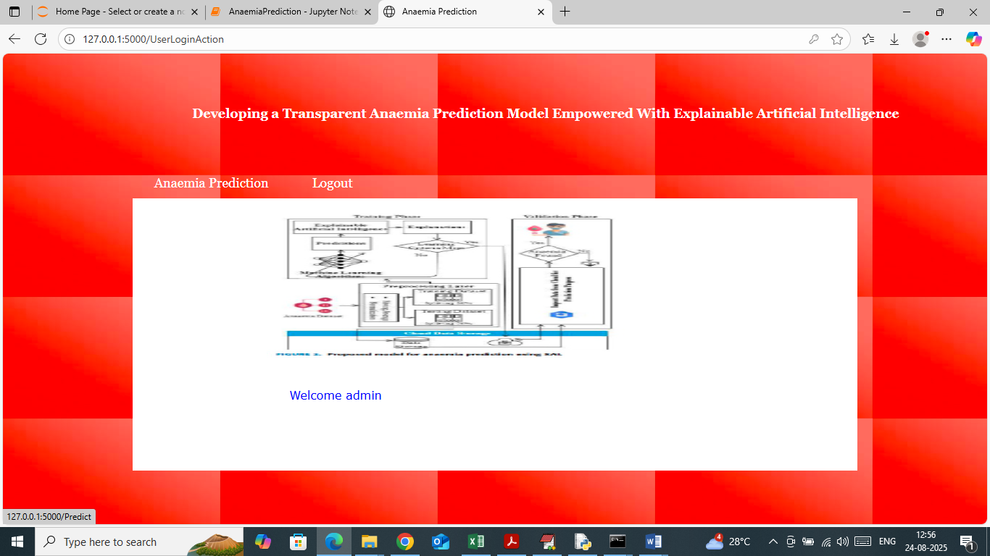

In above screen click on ‘Anaemia Prediction’ link to get below page

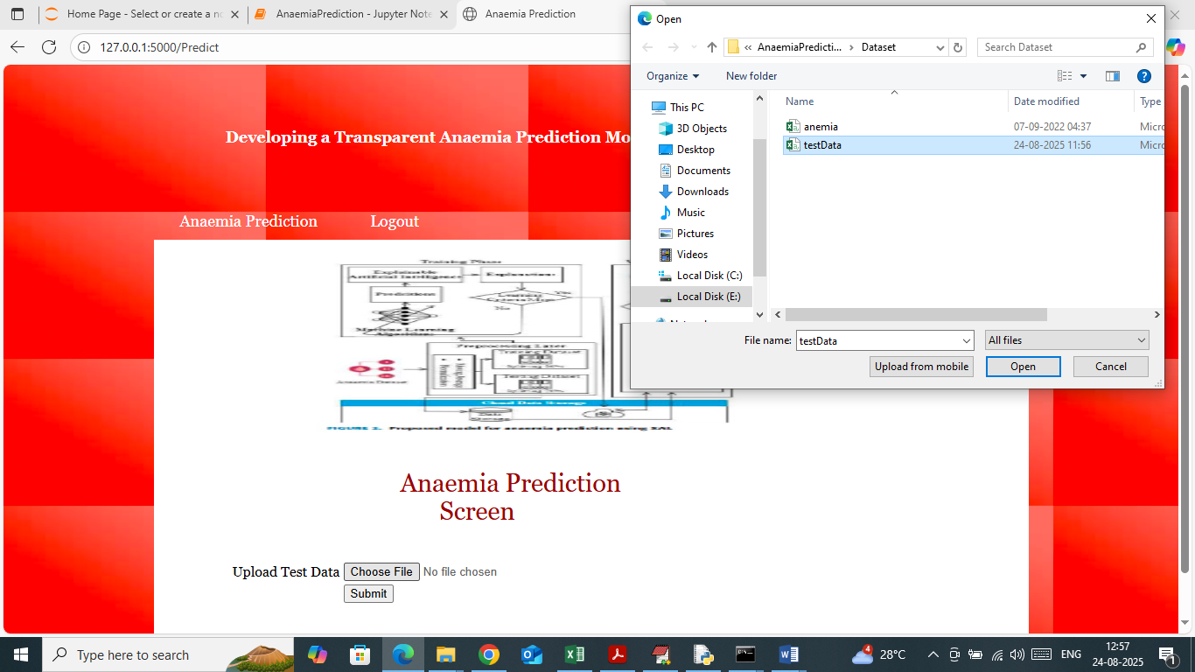

In above screen selecting and uploading test data file and then click on buttons to get below page

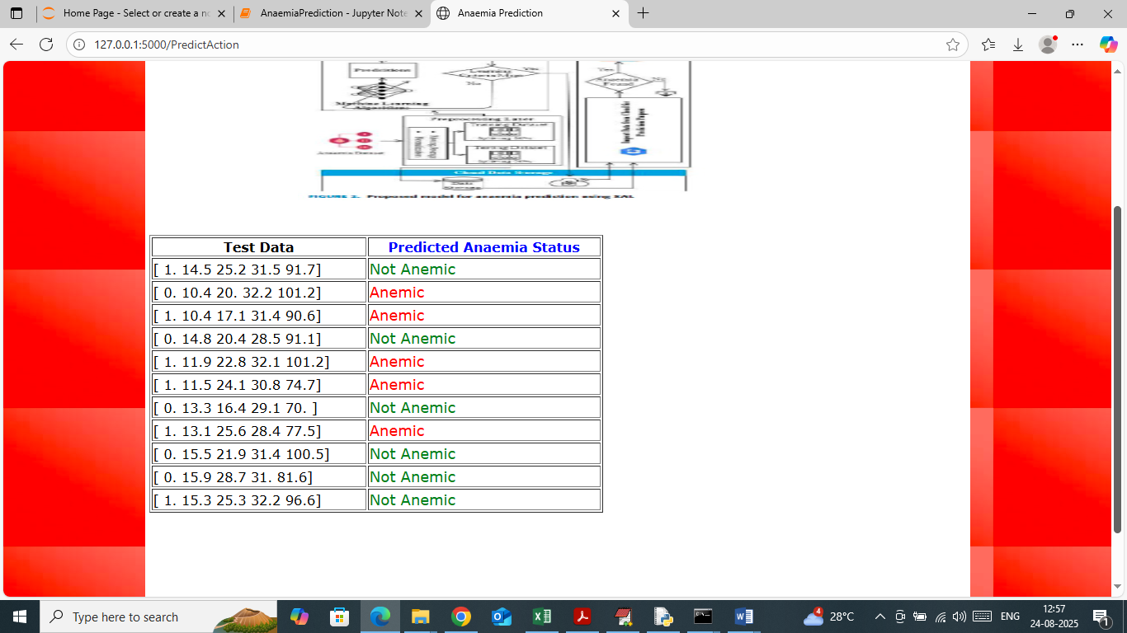

In above screen in first column can see test data values and in second column can see predicted Anaemia type.